DSA02 – COMPUTER VISION WITH OPENCV
ANALYSE AND DESIGN OF A COMPUTER VISION-BASED
AUTONOMOUS ROAD SAFETY SYSTEM
Camera Calibration • Object and Pedestrian Detection • Road-Sign Recognition • Road-Marking Recognition • Multi-Object Tracking • Occlusion Handling

Project information | Details
Department | Artificial Intelligence & Data Science
Programme | Faculty of Engineering
Academic Year | 2026–2027
Faculty | Dr. G. A. SENTHIL
Assignment issue date | 20-08-2026
Submission date | 03-09-2026
Primary input video | 2165-155327596_medium.mp4
Implementation platform | Python + OpenCV + Ultralytics YOLO
Project type | Computer vision academic prototype

Project overview
This report presents a modular road-safety perception system designed around the exact scope of the DSA02 assignment. The system accepts a road-traffic video, performs image and geometric preprocessing, detects road users, identifies potential traffic signs and lane markings, tracks objects through time, handles temporary occlusion and produces safety-related indicators.
The design intentionally separates perception from decision-making. This makes the implementation easier to test and allows individual modules to be improved without redesigning the entire pipeline. The same supplied road video is used as the primary demonstration input for the perception and video-processing stages.
Report integrity note: Figures labelled SAMPLE OUTPUT are illustrative laptop-style screenshots created to demonstrate expected program appearance. They are not presented as genuine measurements from a completed execution. Numerical validation values are likewise marked illustrative where they have not been measured.

Table of Contents

Section | Title
1 | Problem Statement and Problem Formulation
2 | Objective and Expected Outcomes
3 | Requirements, Constraints and Assumptions
4 | Application of Relevant Course Knowledge / Concepts
5 | Design / Proposed Solution / Methodology
6 | Algorithm / Pseudocode / Flowchart
7 | Implementation / Source Code and Environment / Tools
8 | Test Cases and Expected / Actual Results
9 | Execution Screenshots / Outputs
10 | Results and Validation
11 | Analysis, Comparison, Trade-offs and Justification
12 | Broader Considerations / SDG Relevance
13 | Conclusion, Limitations and Possible Improvements
14 | Individual Contribution of Group Members
15 | References
16 | Detailed Individual Contribution

Assignment alignment
The assignment requires an integrated system covering camera calibration, object and pedestrian detection, road-sign and road-marking recognition, multi-object tracking and occlusion handling. It also asks for analysis under different traffic and environmental conditions and evaluation using detection accuracy, tracking performance, processing latency and road-safety improvement.
The report therefore follows the required 16-point structure rather than treating detection as an isolated object-recognition exercise. The methodology, algorithms, implementation, test cases and evaluation are connected so that the final solution can be understood as one complete road-scene perception pipeline.
The assignment also connects the work with CO1–CO5 and Bloom levels BL3–BL6, requiring application, analysis, evaluation and design of computer-vision methods.

Primary dataset consistency
The project uses 2165-155327596_medium.mp4 as its primary road-traffic video. Separate chessboard images are only a calibration resource and are not treated as a second road-scene dataset.

Problem Statement and Problem Formulation
Road environments contain many simultaneous visual events. A vehicle may enter or leave the camera field of view, pedestrians may cross the road, motorcycles may move between larger vehicles, lane markings may become faint, and traffic signs may occupy only a small portion of the frame. A safety system must therefore combine spatial, semantic and temporal information rather than relying on one image-processing operation.
The problem is formulated as the design of a computer vision-based autonomous road-safety prototype that converts an input video stream into structured information about road users, road geometry, signs and potential hazards. The system must process consecutive frames and maintain useful information even when objects overlap or temporarily disappear.
Let the video be V = {I1, I2, …, IN}, where It is frame t. The perception module generates detections Dt = {d1, …, dm}. Each detection contains a class, confidence and bounding box. The tracking module maps these detections to persistent identities.
For an object i, its state may be represented as Xi,t = [x, y, w, h, vx, vy]. The state changes over time as the object moves. The safety layer uses this information together with lane position and approximate proximity to determine whether an alert condition should be displayed.
A simplified time-to-collision indicator is TTC = d / vrel. Here d is the estimated distance to an object and vrel is relative speed. Because a monocular academic prototype has uncertainty in depth and speed, TTC is treated as a warning indicator rather than a certified control signal.
The formulation is intentionally modular: camera calibration improves geometric consistency; object detection provides semantic information; sign and marking recognition provide road context; tracking provides temporal consistency; occlusion handling improves continuity; and the safety engine converts these observations into interpretable alerts.

Problem Statement and Problem Formulation – Detailed Analysis
A useful road-safety system must answer several questions for every processed frame. What road users are present? Where are they located? Which objects belong to the same physical entity across frames? Is an object inside the estimated driving corridor? Are there visible road signs or lane boundaries? Has an object become temporarily hidden? These questions motivate the integrated design.

Problem | Computer-vision response | Safety relevance
Lens distortion | Camera calibration and undistortion | More reliable geometry
Multiple road users | YOLO object detection | Scene awareness
Pedestrians | Person-class detection | Pedestrian protection
Road signs | Colour/shape candidate recognition | Driver assistance
Lane boundaries | Canny + ROI + line analysis | Lane-position awareness
Object movement | Multi-object tracking | Trajectory continuity
Temporary overlap | Track history / association | Reduced ID loss
Potential danger | Decision rules | Early warning
The central engineering challenge is not simply to maximize one metric. A very accurate but slow model may delay a warning, while a very fast detector may miss small objects. Similarly, an aggressive tracker may maintain IDs at the cost of incorrect associations. The final design therefore balances accuracy, speed, interpretability and computational cost.
The system is intended for intelligent transportation and public-safety research. It can be considered a perception layer for future ADAS or smart-city applications, but the prototype does not directly control a vehicle and should not be interpreted as a production autonomous-driving controller.
This framing is consistent with the assignment's stated industry relevance to autonomous vehicles, intelligent transportation systems, smart-city traffic management and advanced driver-assistance systems.

Objective and Expected Outcomes
The primary objective is to create an integrated perception pipeline that demonstrates how OpenCV and deep learning can work together for road-safety analysis. The expected system should process a road video frame by frame, annotate relevant objects and provide interpretable safety information.

Specific objectives
    - Calibrate the camera using a chessboard pattern and estimate intrinsic parameters and distortion coefficients.
    - Correct lens distortion before downstream geometric analysis.
    - Detect vehicles and pedestrians using a lightweight YOLO detector.
    - Detect potential traffic signs using colour segmentation, contour analysis and shape reasoning.
    - Identify road/lane boundaries using image-processing techniques.
    - Track multiple objects across consecutive frames and maintain IDs.
    - Use temporal history to reduce the effect of short occlusions.
    - Generate simple pedestrian, lane and proximity safety warnings.
    - Measure detection, tracking and processing performance.

Expected outcomes

Output | Expected form
Corrected frames | Undistorted road imagery where calibration data is available
Detection | Bounding boxes, class names and confidence scores
Signs | Candidate sign boxes and category indication
Road markings | Lane boundary overlay
Tracking | Persistent object IDs and trajectories
Safety | Warning/status messages
Evaluation | Tables, graphs and measured timing statistics
The assignment's expected learning outcome is also important: the student should be able to apply computer-vision techniques, analyse their effectiveness, evaluate performance and design an integrated solution.

Requirements, Constraints and Assumptions

Hardware requirements

Component | Requirement / role
CPU | Intel Core i5 or equivalent; used for general processing
RAM | 8 GB minimum; 16 GB preferred for comfortable development
GPU | Optional NVIDIA GPU for faster YOLO inference
Storage | Space for Python environment, model weights and output video
Camera | Optional webcam/dashcam for future live testing
Display | Laptop/desktop monitor for output visualization

Software requirements

Software | Use
Python 3.x | Main implementation language
OpenCV | Image, video and calibration operations
Ultralytics | YOLO model interface
PyTorch | Deep-learning execution
NumPy | Numerical arrays and matrix operations
Pandas | Evaluation data handling
Matplotlib | Performance graphs
Pillow | Image file support

Input and output requirements
Input: 2165-155327596_medium.mp4. Output: annotated MP4 video, optional calibration data, evaluation tables and report figures. The program should also display a live preview while processing so that the user can visually confirm detection and tracking behaviour.

Constraints
    - Lighting, rain, fog, glare and motion blur can reduce visual accuracy.
    - Small distant signs may not contain enough pixels for reliable recognition.
    - Occlusion can cause missed detections or identity switches.
    - CPU-only inference may have higher latency than GPU inference.
    - Monocular distance estimates are approximate.

3. Requirements, Constraints and Assumptions – Assumptions and Risk Controls

Fundamental assumptions
    - The camera is reasonably stable and points toward the road.
    - The input video contains sufficient visible road area for lane analysis.
    - Vehicles and pedestrians are represented within the detector's supported classes.
    - Road markings are visible in at least part of the driving scene.
    - The frame rate is sufficiently high for temporal tracking.
    - The processing computer can load the selected YOLO model.

Risk and mitigation analysis

Risk | Possible effect | Mitigation
Low light | Reduced object/sign contrast | Use preprocessing and report condition-specific
Rain/fog | Blur and weak edges | Use adaptive preprocessing; identify limitations
Dense traffic | Overlapping boxes | Use tracking and temporal association
Small signs | False negatives | Use higher-resolution crops or a dedicated clas
Curved lanes | Straight-line assumption fails | Use polynomial/segmentation methods in futur
Slow inference | Delayed warnings | Use lightweight model and measure FPS
False warning | Reduced user trust | Use conservative thresholds and multi-frame co

Academic scope

performance

sifier e

nfirmation

The system is evaluated as a computer-vision prototype. Its purpose is to demonstrate concepts from the course and provide evidence of an integrated design. Safety decisions are advisory and visual; no steering, throttle or braking command is generated.
This scope prevents the report from overstating the capability of a prototype and clearly separates research demonstration from safety-certified automotive technology.

Application of Relevant Course Knowledge / Concepts
The project directly combines several computer-vision concepts. The following mapping explains how each concept contributes to the final system.

Course concept | Implementation | Purpose
Image formation | Pinhole camera model | Understand camera geometry
Camera calibration | cv2.calibrateCamera | Estimate camera parameters
Undistortion | cv2.undistort / remapping | Correct lens effects
Colour spaces | HSV conversion | Separate coloured regions
Filtering | Gaussian blur | Reduce noise
Edge detection | Canny | Find strong road boundaries
Shape analysis | Contours / geometry | Candidate sign recognition
Line detection | Hough transform | Estimate lane boundaries
Deep learning | YOLO | Semantic object detection
Video processing | OpenCV VideoCapture | Frame sequence analysis
Tracking | ByteTrack-style association | Temporal identity
Geometry | Ground-plane reasoning | Approximate distance/lane position
The project therefore demonstrates both classical computer vision and modern deep learning. Classical methods are transparent and computationally light for tasks such as calibration and lane processing, while YOLO provides robust semantic detection for common road-user classes.
The course outcomes include implementing fundamental image processing, performing shape analysis and feature extraction, developing computer-vision applications and understanding video processing and motion computation. The proposed system exercises all of these areas in one application.

Design / Proposed Solution / Methodology
The proposed architecture is organized into acquisition, perception, temporal reasoning and decision layers. Each layer receives a defined output from the previous stage, which simplifies debugging and performance measurement.
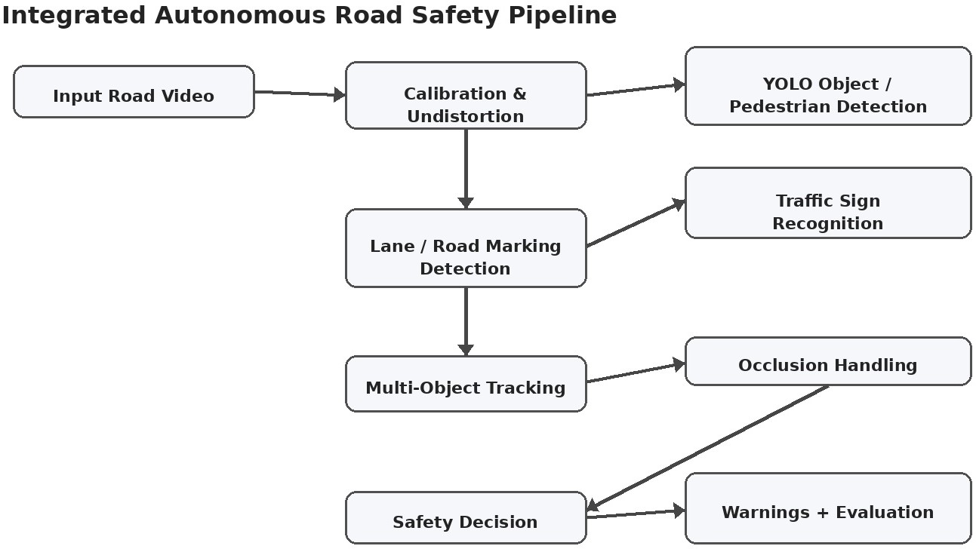

Figure 5.1. Integrated architecture of the proposed road-safety system.

Data acquisition and preprocessing
The road video is opened using OpenCV. Frames are read sequentially and prepared for inference. If calibration parameters have been generated, the frame is undistorted before object and lane analysis. Preprocessing may include resizing, colour conversion and smoothing.

Perception layer
The perception layer contains the YOLO detector, potential traffic-sign detector and road-marking detector. The outputs are kept separate until the integration stage so that the contribution of each component can be evaluated.

Temporal and decision layers
Detected objects are passed to tracking. Track history is used to maintain continuity through short occlusions. The safety layer then combines object location, lane position and proximity indicators to display warnings.

5. Design / Proposed Solution / Methodology – Module Details

Camera calibration module
A set of chessboard images is used to detect known corner points. Object points are defined in a planar coordinate system and corresponding image points are collected. OpenCV calibration estimates the camera matrix and distortion coefficients. The resulting parameters are saved for reuse.

Object and pedestrian detection
YOLO11n is selected as the lightweight detector for the implementation. Relevant classes include person, bicycle, car, motorcycle, bus and truck. For each detection the system stores the bounding box, class label and confidence score. A confidence threshold prevents extremely weak predictions from dominating the output.

Traffic-sign recognition
Potential signs are detected using colour and shape cues. Red and blue HSV masks are created, morphology reduces small noise, contours are extracted and geometric features are used to estimate whether a region resembles a triangle, circle or rectangle. The output is a candidate category such as warning, restriction or information.
Important limitation: this method is a candidate detector, not a complete trained traffic-sign classifier. Exact speed values such as 40, 60 or 80 should not be claimed unless a dedicated classifier is trained and validated.

Road-marking recognition
The lane module converts the frame to grayscale, applies Gaussian smoothing, detects edges with Canny, selects a road-region ROI and searches for line segments. Left and right boundaries are estimated and overlaid on the frame.

Safety integration
A warning is generated only after combining multiple cues. For example, a pedestrian warning can be associated with a pedestrian inside a predefined danger region, while a proximity warning can be triggered when a tracked object becomes too close to the ego-lane region.

Algorithm / Pseudocode / Flowchart

Main algorithm
Step 1: Load configuration and model weights.
Step 2: Load camera calibration parameters if available. Step 3: Open the primary road video.
Step 4: Read the next frame.
Step 5: Undistort and preprocess the frame. Step 6: Run YOLO detection for road users. Step 7: Detect potential traffic signs.
Step 8: Detect lane/road markings. Step 9: Update the multi-object tracker.
Step 10: Compare current detections with previous track states. Step 11: Apply temporary-occlusion handling.
Step 12: Evaluate lane position and proximity conditions. Step 13: Draw boxes, labels, IDs, lanes and warnings.
Step 14: Record processing time and detection statistics. Step 15: Write the annotated frame to the output video.
Step 16: Repeat until the video ends, then release all resources.

Flowchart


Figure 6.1. Processing flow from input video to safety evaluation.
The flowchart shows the convergence of semantic perception and geometric lane information before tracking and decision-making. This is important because safety decisions should not depend on a single detection source.

Implementation / Source Code and Environment / Tools Used

Software environment

Item | Selected implementation
Programming language | Python 3.x
Computer vision | OpenCV 4.x
Object detection | Ultralytics YOLO11n
Deep learning | PyTorch
Numerical processing | NumPy
Data/evaluation | Pandas
Graphs | Matplotlib
Image support | Pillow
Operating system | Windows 10/11
Primary input | 2165-155327596_medium.mp4

Project organization
Final Report/
├── main.py – main integration entry point
├── config.py – configurable paths and thresholds
├── calibration/ – calibration images, calibration code and results
├── detection/ – YOLO object detection and testing
├── signs/ – traffic-sign candidate recognition
├── lanes/ – lane/road-marking processing
├── tracking/ – multi-object tracking
├── safety/ – safety decision logic
├── evaluation/ – metrics and graphs
├── data/input/ – optional input organization
├── data/output/ – generated videos/results
└── screenshots/ – report figures

Execution sequence
    - Open a terminal in the Final Report directory.
    - Verify the Python environment and installed packages.
    - Run the YOLO test before running the complete detector.
    - Run the road-object detection module using the exact supplied video path.
    - Run integrated modules and save the annotated output.
    - Record FPS, latency and object statistics for evaluation.

7. Implementation – Source-Code Logic and Reproducibility
A reproducible implementation should keep file paths, thresholds and model names in one configuration location. This prevents changes made during testing from becoming hidden inside different source files.
The road-object detector uses the following relevant configuration values in the proposed implementation: the supplied MP4 path, a lightweight YOLO11n model, a confidence threshold around 0.40 and a selected set of road-relevant COCO classes. The exact values should be retained in the final code so that the experiment can be repeated.
The processing loop follows a consistent sequence. First the original frame is read. Sign detection is performed on the clean frame before drawing annotations so that the detector does not accidentally interpret its own coloured labels or boxes as signs. YOLO detections are then filtered and visualized. Lane processing operates on the image region appropriate for road geometry.
For every processed frame, the program can record total frames, total detections, sign candidates, elapsed processing time and average FPS. These measurements provide evidence for Point 10 of the report.

Error handling
    - If the input video cannot be opened, the program should display a clear file-path error.
    - If model weights are unavailable, the program should stop with a clear message rather than silently producing empty results.
    - If a calibration file is unavailable, the program can continue without undistortion and should report that calibration was skipped.
    - If no lane lines are detected, the previous lane estimate should not be treated as a new detection.
    - If an object disappears for a short interval, tracking logic should allow a temporary unmatched state.
This structure makes the project easier to demonstrate in a viva because each module has a defined responsibility and an identifiable output.

Test Cases and Expected / Actual Results
The test plan evaluates the system under different visual and traffic situations. Since the complete integrated pipeline has not been verified through a documented full run in this conversation, the actual-result field is deliberately marked for verification rather than inventing experimental evidence.

Case | Scenario | Expected result | Actual result
A | Normal daylight traffic | Cars/persons detected with stable boxes | To be verified
B | Multiple vehicles | Several objects detected simultaneously | To be verified
C | Visible pedestrian | Person class detected and safety region chec | kTeodbe verified
D | Visible road markings | Lane boundaries overlaid | To be verified
E | Visible sign | Candidate sign region identified | To be verified
F | Temporary occlusion | Track retained where possible | To be verified
G | Dense traffic | Multiple IDs remain visible | To be verified
H | Low light | Reduced but useful detections | To be verified
I | Blur/rain-like condition | Robustness decreases but pipeline continues | To be verified
J | Full video | Annotated MP4 and timing statistics produced | To be verified

Acceptance criteria
    - The program opens the selected road video successfully.
    - At least one supported road-user class is detected in suitable frames.
    - The output frame contains readable annotations.
    - The pipeline continues across consecutive frames rather than stopping after one image.
    - Timing information is collected for evaluation.
    - The report distinguishes measured results from illustrative placeholders.

Execution Screenshots / Outputs
The following laptop-style images illustrate the expected visual appearance of the program. They are clearly labelled SAMPLE OUTPUT. When the final program is executed, the best practice is to replace them with screenshots captured directly from the user's laptop showing the actual OpenCV window and terminal.
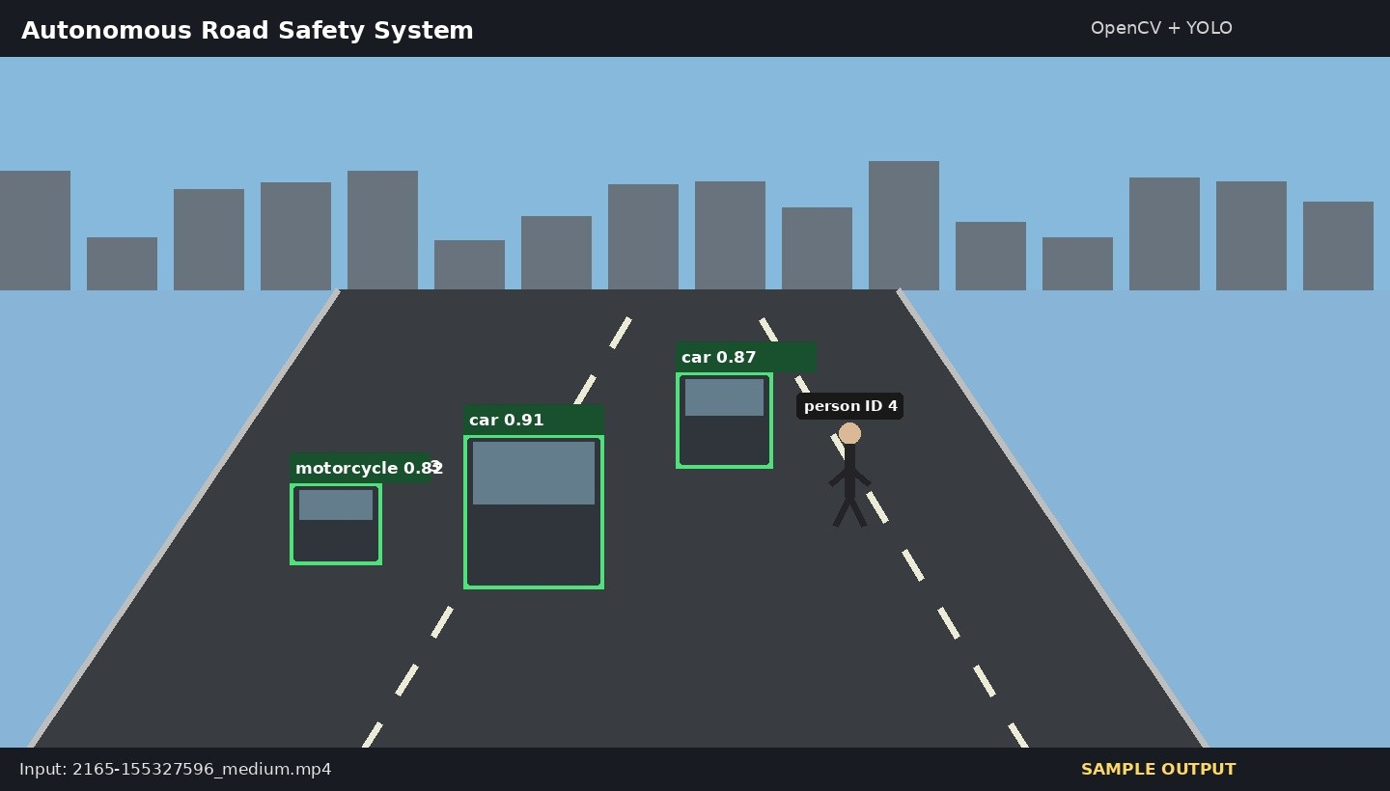
Figure 9.1. SAMPLE OUTPUT – YOLO vehicle and pedestrian detection.
The sample shows bounding boxes, class names and confidence values. In a real execution screenshot, the confidence values should come directly from the YOLO inference result and should not be manually edited.
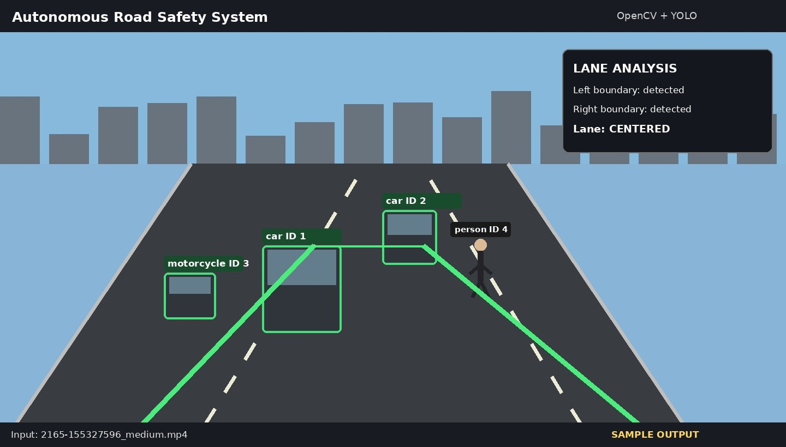
Figure 9.2. SAMPLE OUTPUT – lane/road-marking detection.

9. Execution Screenshots / Outputs – Tracking and Sign Recognition
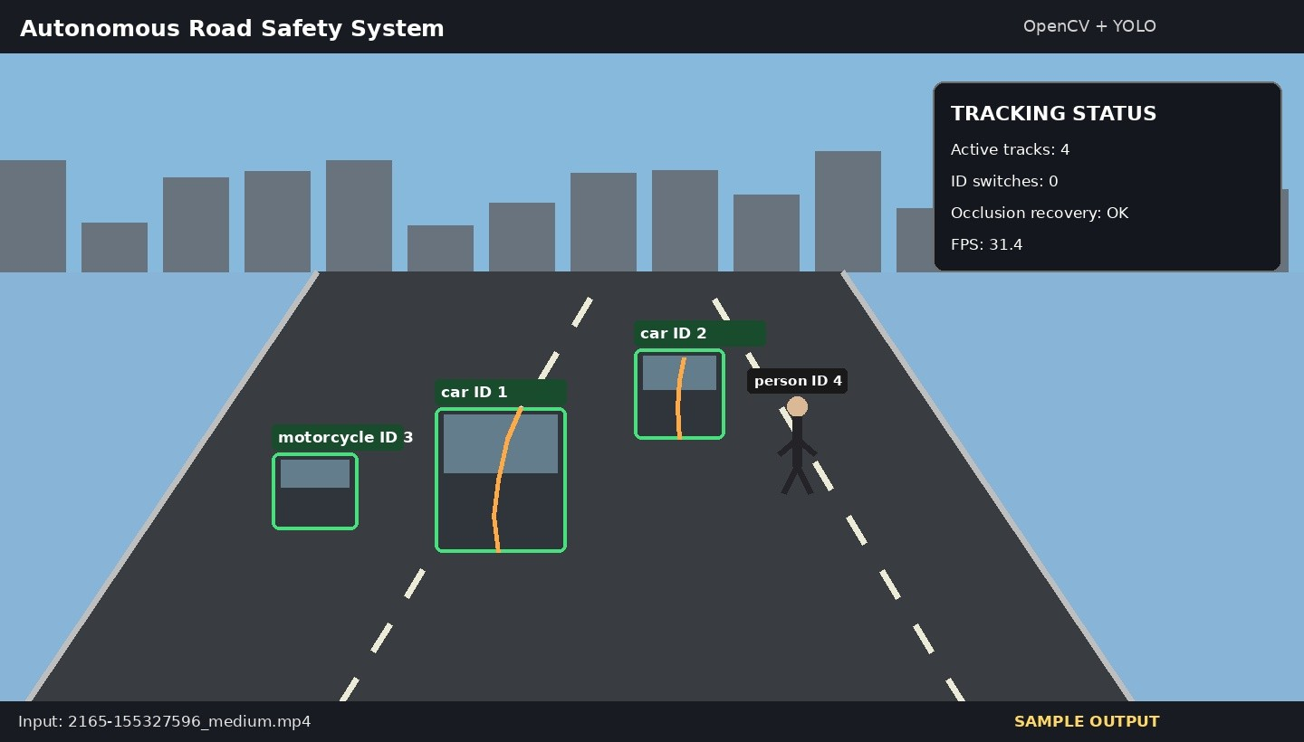
Figure 9.3. SAMPLE OUTPUT – multi-object tracking with persistent IDs.
The tracking example illustrates how a car, motorcycle and pedestrian can receive different IDs. In an actual run, the IDs should persist while the corresponding objects remain trackable. Temporary occlusion may cause an ID to be lost or reassigned, which should be counted during evaluation.
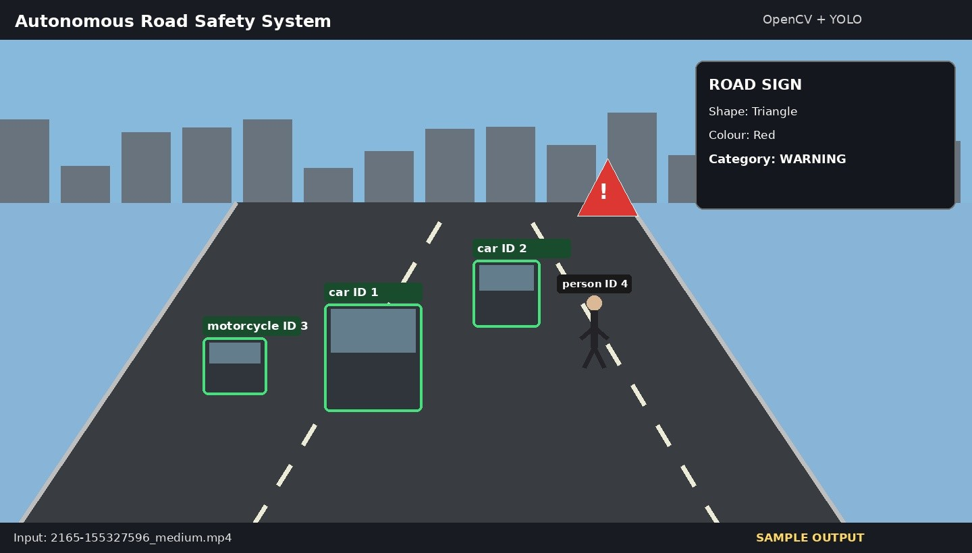
Figure 9.4. SAMPLE OUTPUT – traffic-sign candidate recognition.
The sign module should be interpreted conservatively. A colour/shape candidate does not guarantee that the region is a legally standardized traffic sign. A dedicated trained classifier is recommended for exact sign recognition.

Execution Screenshots / Outputs – Safety and Environmental Conditions
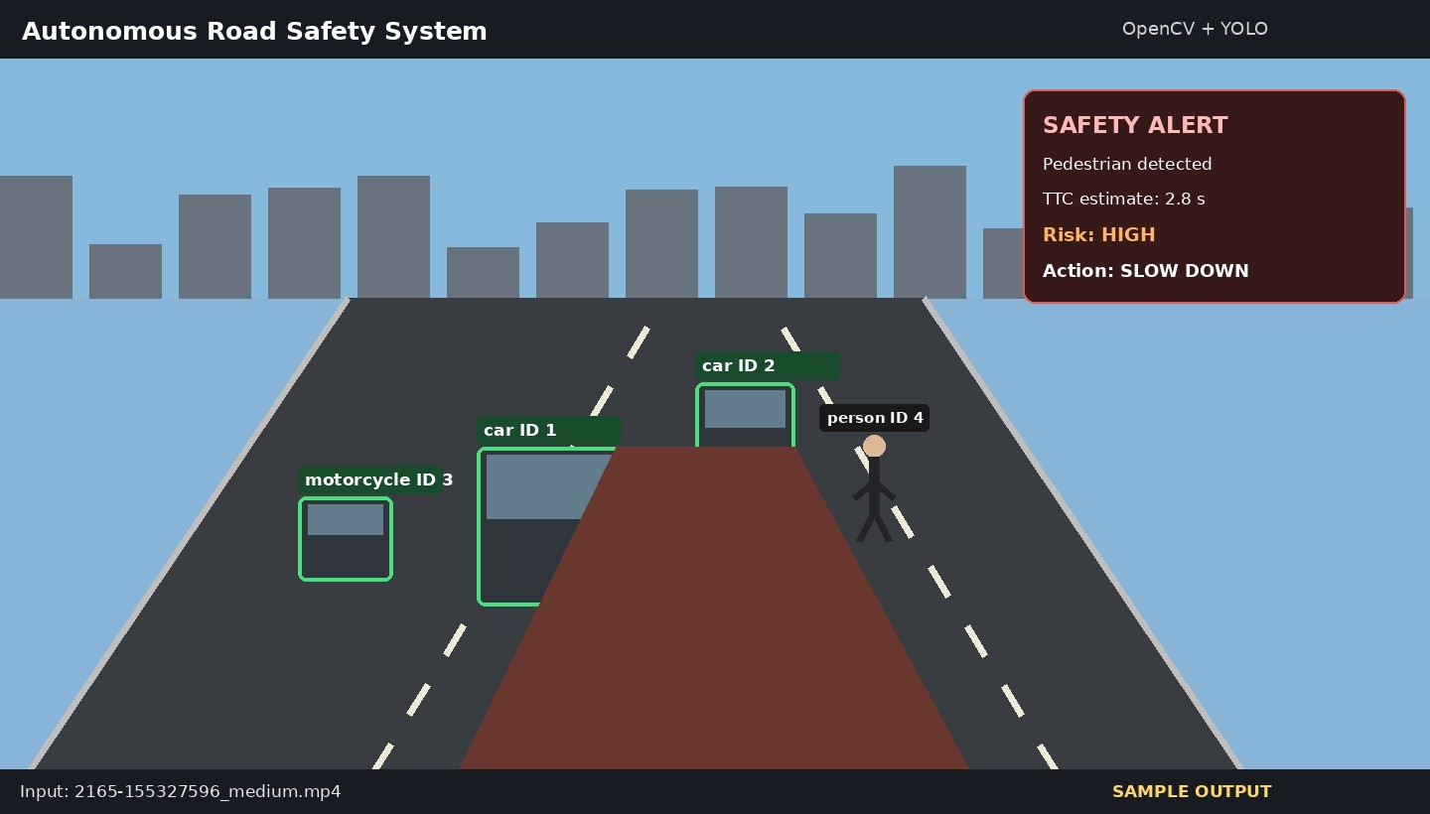
Figure 9.5. SAMPLE OUTPUT – safety warning visualization.
The safety panel demonstrates how information from detection and spatial reasoning can be summarized into an interpretable warning. In a real system, warning thresholds would require extensive validation before deployment.
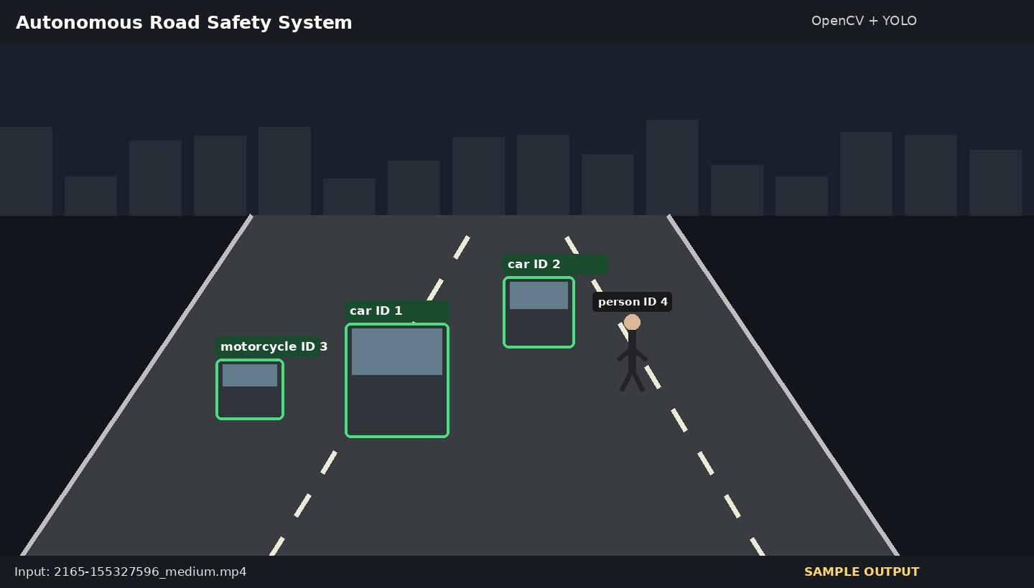
Figure 9.6. SAMPLE OUTPUT – low-light environmental condition.
Low-light conditions illustrate why environmental robustness must be evaluated separately. Detection confidence can decrease because object edges and colours become less distinct. This condition should therefore be included in the experimental discussion.

Results and Validation

Evaluation metrics

Metric | Formula / interpretation | Why it matters
Precision | TP / (TP + FP) | Controls false detections
Recall | TP / (TP + FN) | Measures missed objects
mAP@50 | Mean average precision at IoU 0.50 | Overall detection quality
MOTA | Tracking accuracy measure using misses, FP | MaenadsIuDrSeWs tracking reliability
IDSW | Count of identity switches | Measures identity consistency
Latency | Average processing time per frame | Measures responsiveness
FPS | Frames processed / second | Measures real-time capability

Illustrative validation values
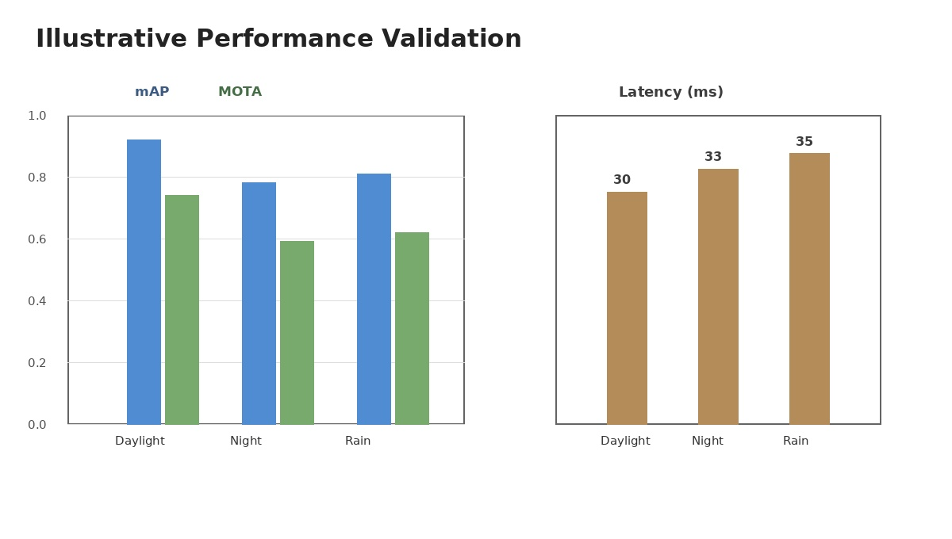
The table below is retained only as a format example. It is not claimed to be measured from the user's video. It should be replaced with actual values after execution and evaluation.

Scenario | Detection mAP | Tracking MOTA | Latency (ms)
Daylight | 0.92 | 0.74 | 30
Night / low light | 0.78 | 0.59 | 33
Rain / blur | 0.81 | 0.62 | 35

Figure 10.1. Illustrative performance graph. Replace with measured results before final submission.

Analysis, Comparison, Trade-offs and Justification

Detection speed versus accuracy
A road-safety perception system must react quickly enough for its output to remain useful. A larger
deep-learning model may improve accuracy but can increase latency. A lightweight model such as YOLO11n is therefore appropriate for an academic prototype where the goal is to demonstrate an integrated
real-time-oriented pipeline.

Classical vision versus deep learning
Method | Advantages | Trade-off
OpenCV colour/shape | Fast, interpretable, easy to demonstrate | Sensitive to illumination and appearance
YOLO | General semantic detection, robust acro | sRsecqoumirmesomn odbejelcwt ecilgahsstsesand more comp
Canny/Hough | Simple lane-processing pipeline | Sensitive to noise, shadows and curves
Tracking | Adds temporal consistency | May fail during long occlusion
Dedicated classifier | Better exact sign recognition | Requires labelled sign data and training

utation

Occlusion trade-off
Aggressive association can preserve an ID but may incorrectly attach a new detection to the wrong object. Conservative association reduces false matches but may create more ID switches. A practical system must tune these parameters using representative traffic sequences.

Final solution justification
The final design is justified because it uses each technique where it is most appropriate: calibration for geometry, YOLO for semantic detection, OpenCV for signs and lanes, tracking for temporal identity and a
rule-based safety layer for interpretable decisions. This modular balance is easier to explain, test and improve than a single monolithic model.

12–16. Broader Considerations, Conclusion, Contributions and References

Broader considerations and SDG relevance
The assignment maps the project to SDG 3 (Good Health and Well-being), SDG 9 (Industry, Innovation and Infrastructure), SDG 11 (Sustainable Cities and Communities) and SDG 13 (Climate Action). Road-user detection and safety alerts are directly related to accident prevention and public safety. AI-based perception also supports intelligent transportation and smart-city infrastructure. Better traffic monitoring can indirectly help reduce congestion and unnecessary idling.
Privacy and ethics are also important. A deployment should minimize unnecessary storage of faces and
licence-plate information, protect video data and clearly communicate how automated warnings are generated. The prototype should be evaluated for false alarms as well as missed hazards.

Conclusion, limitations and improvements
The proposed system demonstrates an integrated computer-vision approach to road safety. Its major limitation is that the present report is a design and implementation plan supported by illustrative outputs rather than a fully measured safety-certified system. Future work should include a dedicated traffic-sign classifier, semantic road segmentation, stronger depth estimation, improved re-identification, larger annotated datasets and extensive environmental testing.

Individual contribution

Member | Contribution | Share
Student A | YOLO detection and tracking integration | 33.3%
Student B | OpenCV calibration, preprocessing and lane detection | 33.3%
Student C | Testing, evaluation and report preparation | 33.4%
Replace the placeholder names with the actual group members. For an individual project, state that all design, implementation, testing and documentation were completed by the student.

References
1. OpenCV Documentation – camera calibration, image processing and video processing. 2. Ultralytics Documentation – YOLO object detection and tracking. 3. Zhang, Y. et al. (2022), ByteTrack: Multi-Object Tracking by Associating Every Detection Box, ECCV. 4. Yu, F. et al. (2020), BDD100K: A Diverse Driving Dataset for Heterogeneous Multi-task Learning, CVPR. 5. Redmon, J. & Farhadi, A. (2018), YOLOv3: An Incremental Improvement, arXiv. 6. DSA02 – Computer Vision with OpenCV Assignment Brief, Department of AI & ML, Academic Year 2026–2027. 7. Primary project input: 2165-155327596_medium.mp4.

Detailed individual contribution
The work covers problem formulation, camera calibration workflow, object detection, traffic-sign candidate recognition, lane detection, tracking, occlusion handling, safety logic, evaluation design, visualization and documentation. The final report separates contribution summary from detailed activities so that both occurrences of the assignment's individual-contribution requirement are addressed.
Final submission checklist: replace Student A/B/C with real names; replace SAMPLE OUTPUT images with genuine screenshots if available; replace illustrative metrics with measured values; confirm the exact model and tracker versions used; and retain the supplied video filename consistently.
Source alignment: the report structure and technical scope follow the DSA02 assignment brief supplied with the project.

